Assignment-24.4:

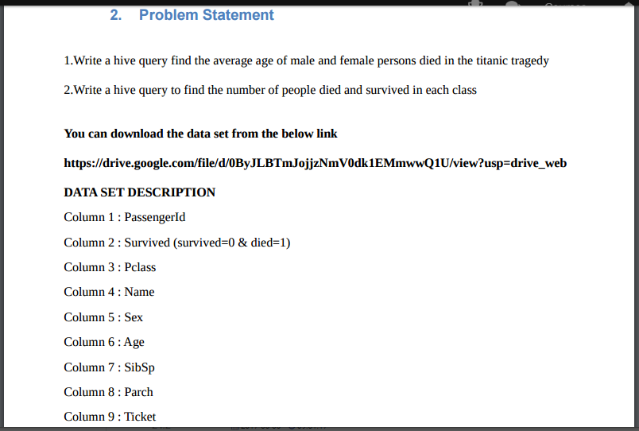

A table named titanic is created and the data is loaded into the table. The below screenshot describes the columns of the titanic table.

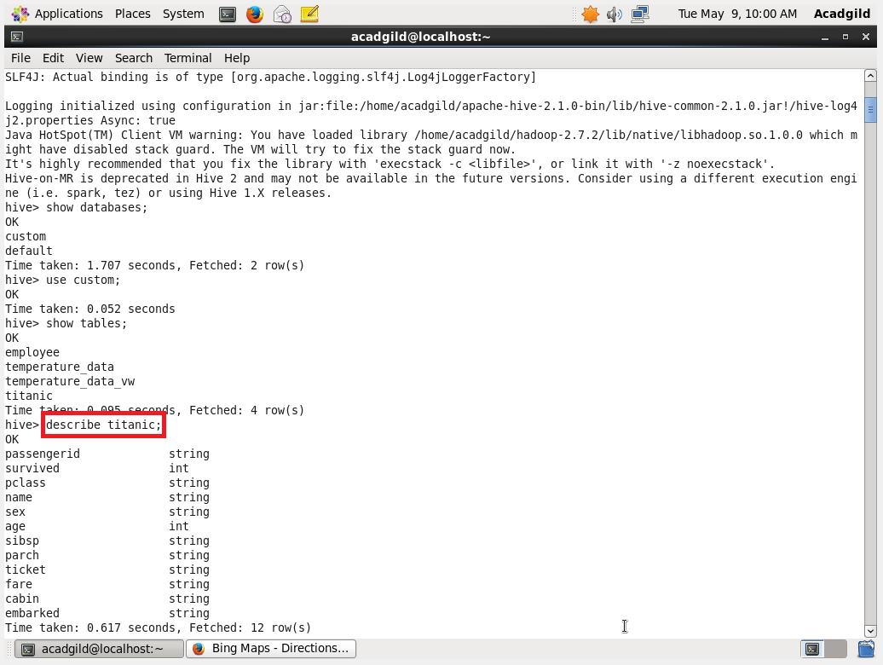

1. Write a hive query find the average age of male and female persons died in the titanic tragedy

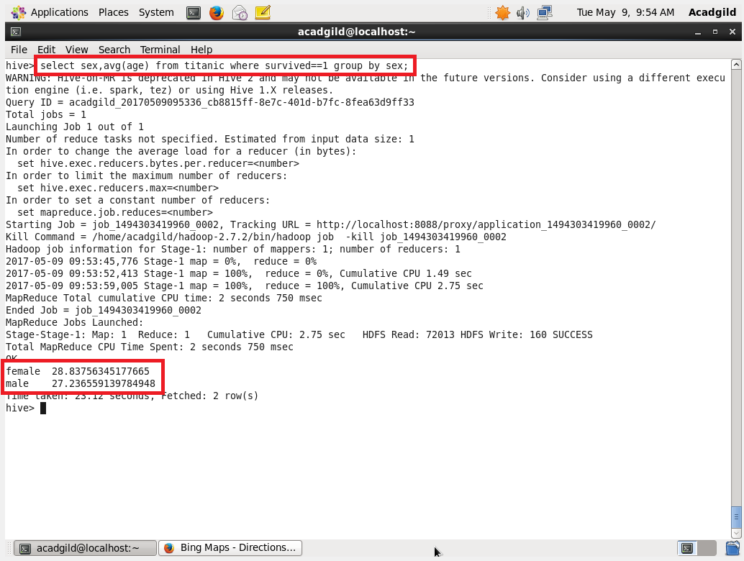

2. Write a hive query to find the number of people died and survived in each class.

